John Michael Go
Career Entry Level Java Programming
Date: Jan. 16, 2013

DAY 4

Program Name: Loop3

Objective: Program that loops using do while statement.

Algorithm:

- Program displays the value of x between 10 to 20.

Flowchart:

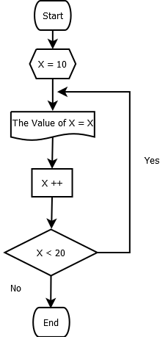

Pseudocode:

public class Loop3 {

public static void main(String[] args) {

int x = 10;
do
{
System.out.println("The value of x = " +x);
x++;

} while (x < 20);

}

}

Screenshot:

